**WEEK 2 – ASSIGNMENT**

**Superset ID:** 6390124

**PL/SQL Exercises:-**

**Schema to be Created:**

CREATE TABLE Customers (

CustomerID NUMBER PRIMARY KEY,

Name VARCHAR2(100),

DOB DATE,

Balance NUMBER,

LastModified DATE,

IsVIP CHAR(1)

);

CREATE TABLE Accounts (

AccountID NUMBER PRIMARY KEY,

CustomerID NUMBER,

AccountType VARCHAR2(20),

Balance NUMBER,

LastModified DATE,

FOREIGN KEY (CustomerID) REFERENCES Customers(CustomerID)

);

CREATE TABLE Loans (

LoanID NUMBER PRIMARY KEY,

CustomerID NUMBER,

LoanAmount NUMBER,

InterestRate NUMBER,

StartDate DATE,

EndDate DATE,

FOREIGN KEY (CustomerID) REFERENCES Customers(CustomerID)

);

CREATE TABLE Employees (

EmployeeID NUMBER PRIMARY KEY,

Name VARCHAR2(100),

Position VARCHAR2(50),

Salary NUMBER,

Department VARCHAR2(50),

HireDate DATE

);

INSERT INTO Customers VALUES (1, 'John Doe', TO_DATE('1960-05-15','YYYY-MM-DD'), 12000, SYSDATE, NULL);

INSERT INTO Customers VALUES (2, 'Jane Smith', TO_DATE('1988-07-20','YYYY-MM-DD'), 8000, SYSDATE, NULL);

INSERT INTO Accounts VALUES (1, 1, 'Savings', 1000, SYSDATE);

INSERT INTO Accounts VALUES (2, 2, 'Checking', 1500, SYSDATE);

INSERT INTO Loans VALUES (1, 1, 5000, 5, SYSDATE, SYSDATE + 20); -- Due in next 30 days

INSERT INTO Employees VALUES (1, 'Alice Johnson', 'Manager', 70000, 'HR', TO_DATE('2015-06-15','YYYY-MM-DD'));

INSERT INTO Employees VALUES (2, 'Bob Brown', 'Developer', 60000, 'IT', TO_DATE('2017-03-20','YYYY-MM-DD'));

COMMIT;

**Exercise 1: Control Structures**

**Scenario 1:** The bank wants to apply a discount to loan interest rates for customers above 60 years old.

**Question:** Write a PL/SQL block that loops through all customers, checks their age, and if they are above 60, apply a 1% discount to their current loan interest rates.

BEGIN

FOR rec IN (

SELECT l.LoanID, l.InterestRate, c.DOB

FROM Loans l

JOIN Customers c ON l.CustomerID = c.CustomerID

) LOOP

-- Calculate age

IF TRUNC(MONTHS_BETWEEN(SYSDATE, rec.DOB) / 12) > 60 THEN

-- Apply 1% discount

UPDATE Loans

SET InterestRate = rec.InterestRate - 1

WHERE LoanID = rec.LoanID;

DBMS_OUTPUT.PUT_LINE('Discount applied to Loan ID: ' || rec.LoanID);

END IF;

END LOOP;

END;

/

**Output:**   
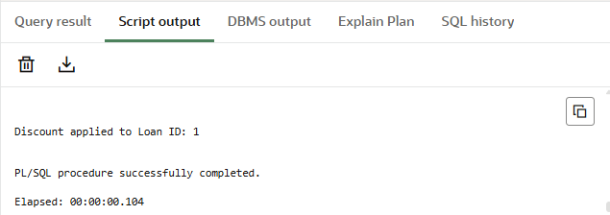

**Scenario 2:** A customer can be promoted to VIP status based on their balance.

**Question:** Write a PL/SQL block that iterates through all customers and sets a flag IsVIP to TRUE for those with a balance over $10,000.

BEGIN

FOR rec IN (

SELECT CustomerID, Balance

FROM Customers

) LOOP

IF rec.Balance > 10000 THEN

UPDATE Customers

SET IsVIP = 'Y'

WHERE CustomerID = rec.CustomerID;

DBMS_OUTPUT.PUT_LINE('Customer ' || rec.CustomerID || ' marked as VIP.');

END IF;

END LOOP;

END;

/  
  
**Output:**

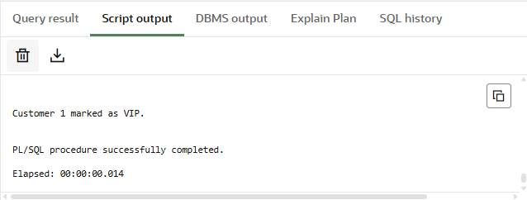

**Scenario 3:** The bank wants to send reminders to customers whose loans are due within the next 30 days.

**Question:** Write a PL/SQL block that fetches all loans due in the next 30 days and prints a reminder message for each customer.  
  
BEGIN

FOR rec IN (

SELECT c.Name, l.LoanID, l.EndDate

FROM Loans l

JOIN Customers c ON l.CustomerID = c.CustomerID

WHERE l.EndDate BETWEEN SYSDATE AND SYSDATE + 30

) LOOP

DBMS_OUTPUT.PUT_LINE('Reminder: Loan ID ' || rec.LoanID ||

' for customer ' || rec.Name ||

' is due on ' || TO_CHAR(rec.EndDate, 'DD-MON-YYYY'));

END LOOP;

END;

/  
  
**Output:  
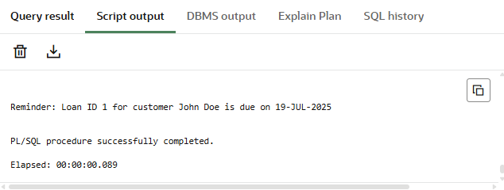**

**Exercise 3: Stored Procedures**

**Scenario 1:** The bank needs to process monthly interest for all savings accounts.

**Question:** Write a stored procedure **ProcessMonthlyInterest** that calculates and updates the balance of all savings accounts by applying an interest rate of 1% to the current balance.

CREATE OR REPLACE PROCEDURE ProcessMonthlyInterest IS

BEGIN

FOR rec IN (

SELECT AccountID, Balance

FROM Accounts

WHERE AccountType = 'Savings'

) LOOP

UPDATE Accounts

SET Balance = rec.Balance + (rec.Balance * 0.01)

WHERE AccountID = rec.AccountID;

DBMS_OUTPUT.PUT_LINE('Interest applied to Account ID: ' || rec.AccountID);

END LOOP;

END;

/

BEGIN

ProcessMonthlyInterest;

END;

/

**Output:  
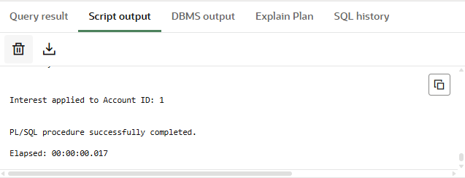**

**Scenario 2:** The bank wants to implement a bonus scheme for employees based on their performance.

**Question:** Write a stored procedure **UpdateEmployeeBonus** that updates the salary of employees in a given department by adding a bonus percentage passed as a parameter.

CREATE OR REPLACE PROCEDURE UpdateEmployeeBonus (

dept_name IN VARCHAR2,

bonus_pct IN NUMBER

) IS

BEGIN

UPDATE Employees

SET Salary = Salary + (Salary * bonus_pct / 100)

WHERE Department = dept_name;

DBMS_OUTPUT.PUT_LINE('Bonus applied to employees in department: ' || dept_name);

END;

/

BEGIN

  UpdateEmployeeBonus('IT', 10);

END;

/

**Output:  
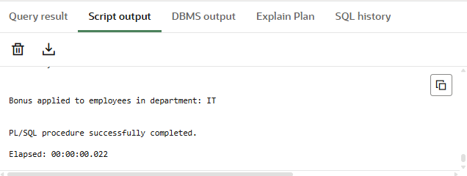**

**Scenario 3:** Customers should be able to transfer funds between their accounts.

**Question:** Write a stored procedure **TransferFunds** that transfers a specified amount from one account to another, checking that the source account has sufficient balance before making the transfer.

CREATE OR REPLACE PROCEDURE TransferFunds (

from_acc IN NUMBER,

to_acc IN NUMBER,

amount IN NUMBER

) IS

from_balance NUMBER;

BEGIN

-- Get source account balance

SELECT Balance INTO from_balance FROM Accounts WHERE AccountID = from_acc;

IF from_balance < amount THEN

RAISE_APPLICATION_ERROR(-20001, 'Insufficient balance in source account.');

END IF;

-- Deduct from source

UPDATE Accounts

SET Balance = Balance - amount

WHERE AccountID = from_acc;

-- Add to destination

UPDATE Accounts

SET Balance = Balance + amount

WHERE AccountID = to_acc;

DBMS_OUTPUT.PUT_LINE('Successfully transferred ' || amount ||

' from Account ' || from_acc || ' to Account ' || to_acc);

EXCEPTION

WHEN OTHERS THEN

DBMS_OUTPUT.PUT_LINE('Transfer failed: ' || SQLERRM);

END;

/

BEGIN

TransferFunds(1, 2, 200);

END;

/

**Output:  
